

Marmara University
Faculty of Engineering
Electronics 1 EE3011

Experiment (4) Diode Characteristics

Department | Student ID | Name Surname
EEE | 150720062 | Mehmet Ali Kamalak

Part (1): Diode Forward IV Characteristics.
Answer:
Yes, the curve resembles the typical diode IV characteristic, starting conduction around 0.6 V. Minor discrepancies are due to measurement errors and diode tolerance.

V | Vd | VR | Id=Vr/R
0.14 | 0.14 | 0 | 0
0.91 | 0.53 | 0.38 | 0.38
1.73 | 0.58 | 1.15 | 1.15
2.37 | 0.6 | 1.77 | 1.77
3.02 | 0.61 | 2.41 | 2.41
4.03 | 0.63 | 3.4 | 3.4
5.06 | 0.64 | 4.42 | 4.42
Table 1: Measurements for Part (1)

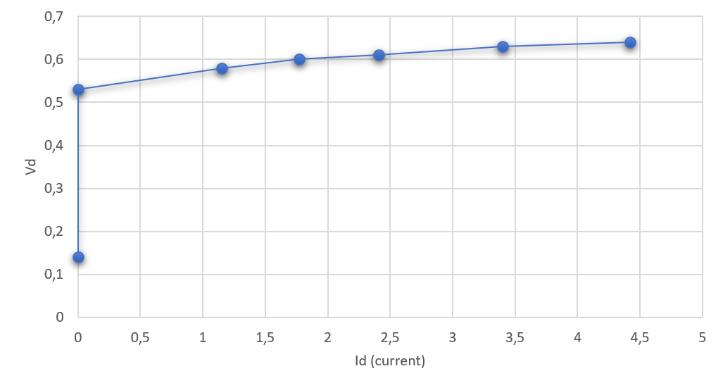
Graph 1: Diode IV Characteristics

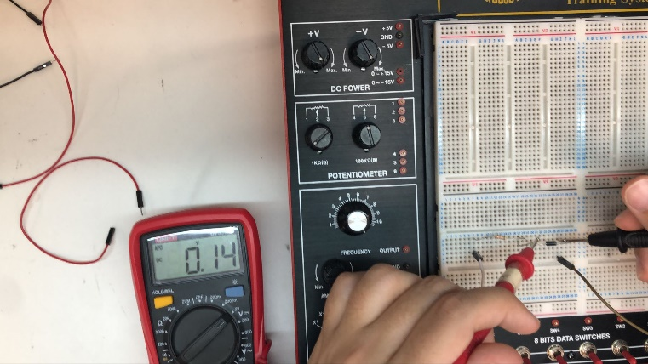
For 0.14V ⇒Vr For 0.14V ⇒ Vd
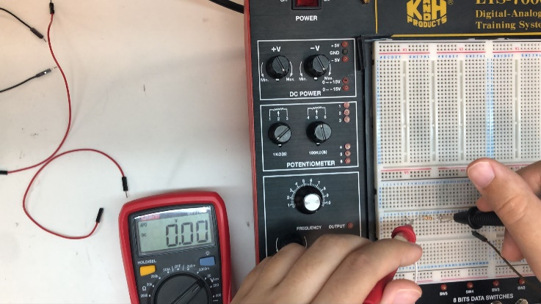
For 0.91V ⇒Vr For 0.91V ⇒ Vd
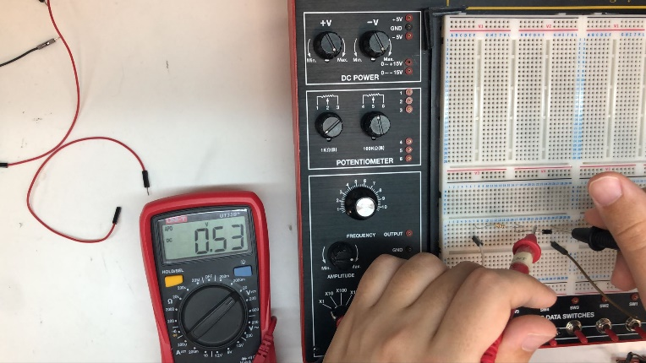
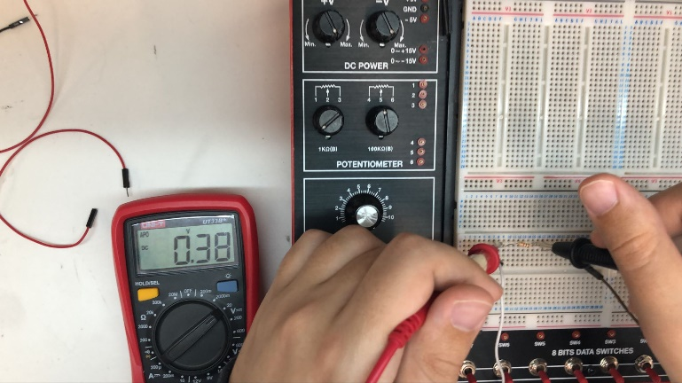

For 1.73V ⇒ Vr For 1.73V ⇒ Vd
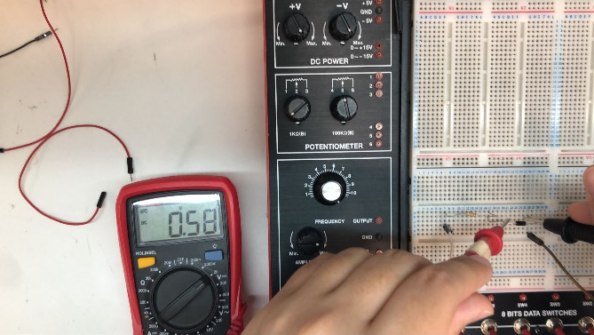
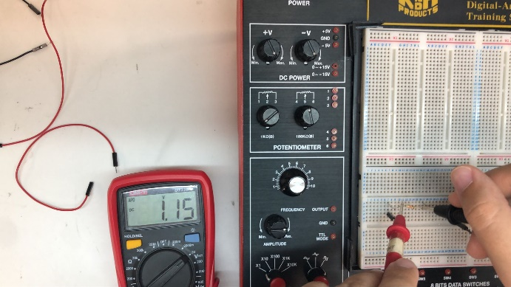

For 3.02V⇒ Vr For 3.02V ⇒ Vd
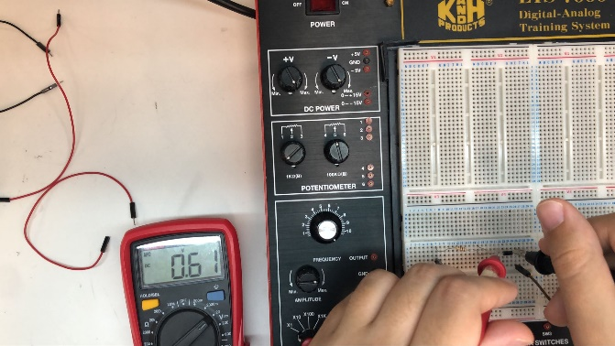
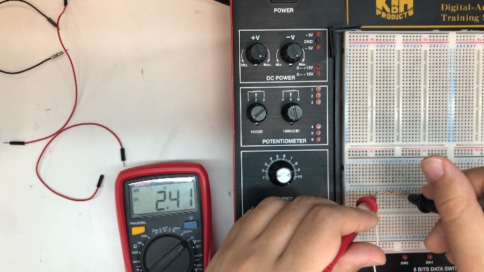
For 4.03V⇒ Vr For 4.03V ⇒ Vd
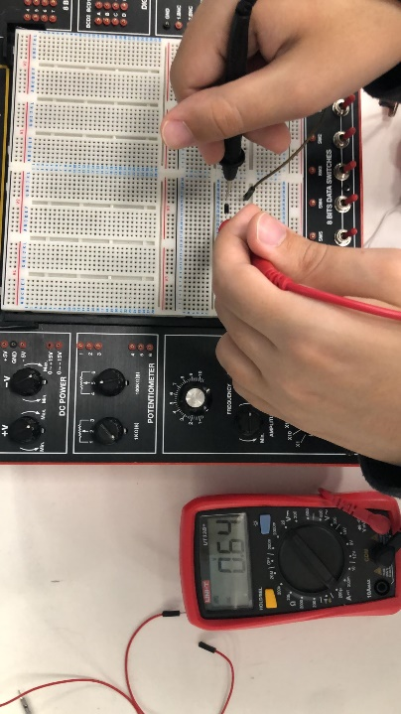
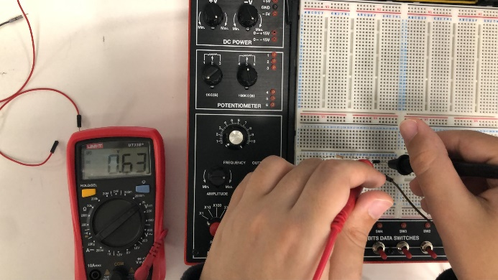
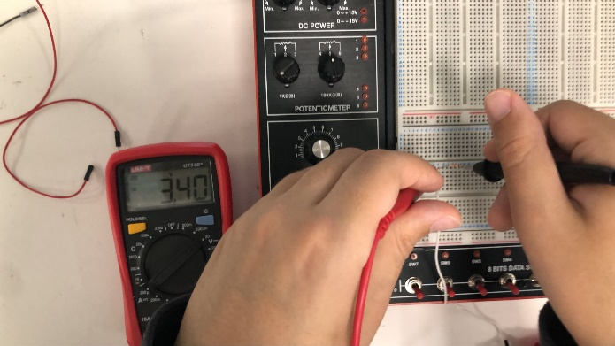
For 5.06V⇒ Vr For 5.06V ⇒ Vd
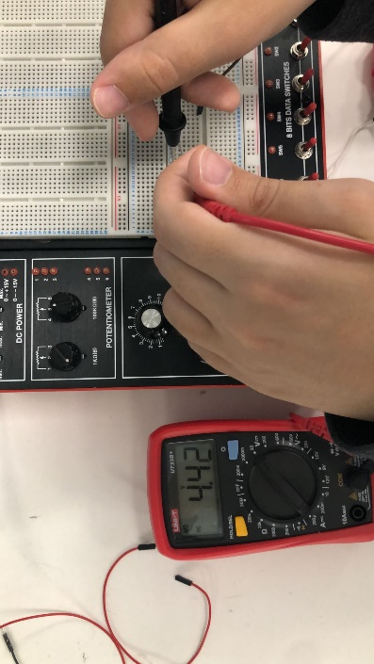

Part (2):Graphical Analysis of Diode Circuits
Diode | Vd | Vr | Id=Vr/R
Included | 0.59 | 1.47 | 1.47
Removed | 0 | 0 | 0
Shorted | 0 | 2V | 2
Table 2: Measurements for Part (2)
𝐼_{𝐷} (mA) Experimental value | 𝐼_{𝐷} (mA) Graphical value | %  Difference | 𝐼_{𝐷} (mA) Theoretical value | %  Difference
1.47 | 1.5 | 2.00% | 1.3 | 13.1%

Table 3: Calculations for Part (2)

Part (3): Diode Application as a Logical Gate
Answer:
They exhibit non-linear behavior and lack amplification capabilities. Logic gates require precise switching characteristics and amplification to ensure reliable operation, which diodes alone cannot provide. Instead, transistors, which offer both amplification and switching capabilities, are predominantly used in logic gate designs.

Va | Vb | Vy
0 | 0 | 0
0 | 5 | 4.33
5 | 0 | 4.38
5 | 5 | 4.4
Table 4: Measurements for Part (3).

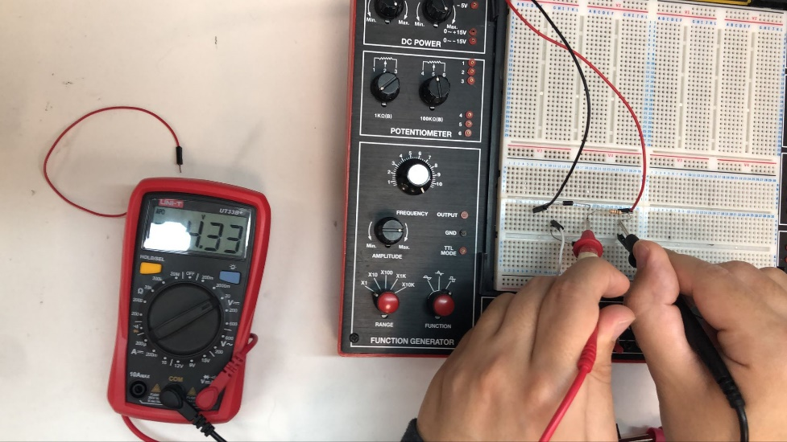
For Va=0 Vb=5 Vy=4.33

For Va=5 Vb=0 Vy=4.38
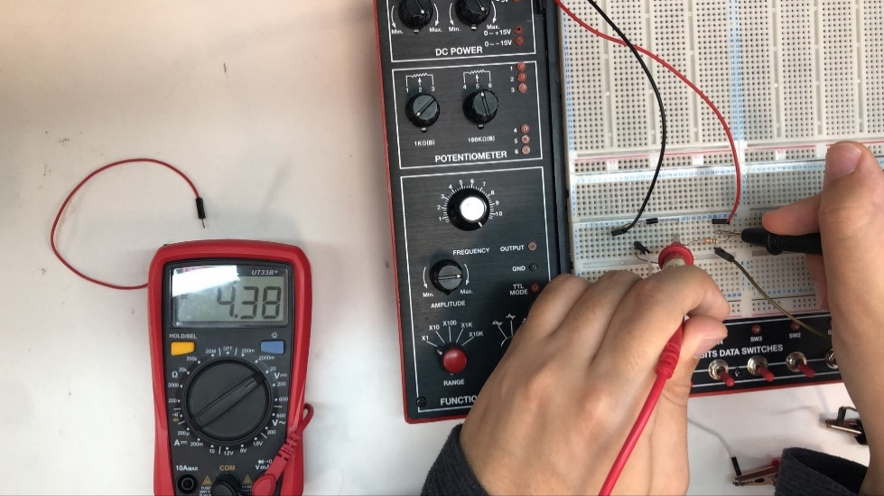
For Va=5 Vb=5 Vy=4.4
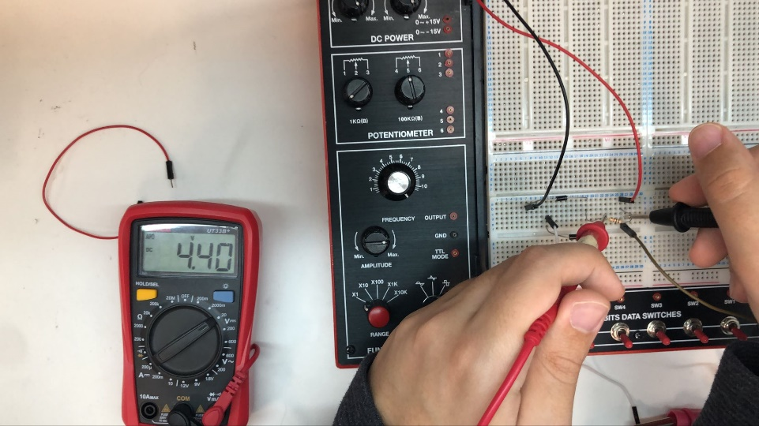

LTspice Simulations and Conclusions and Remarks
Part 1

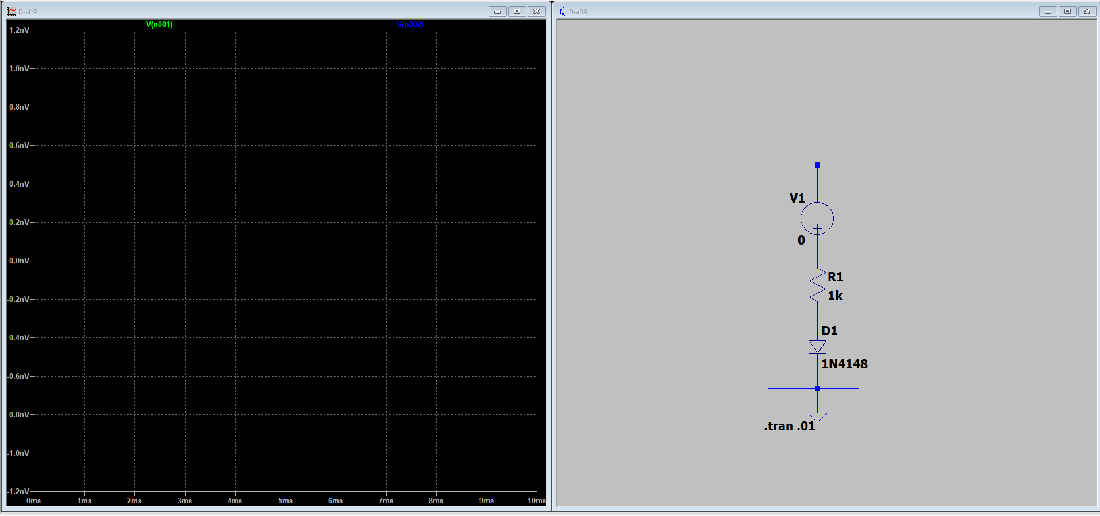

0V

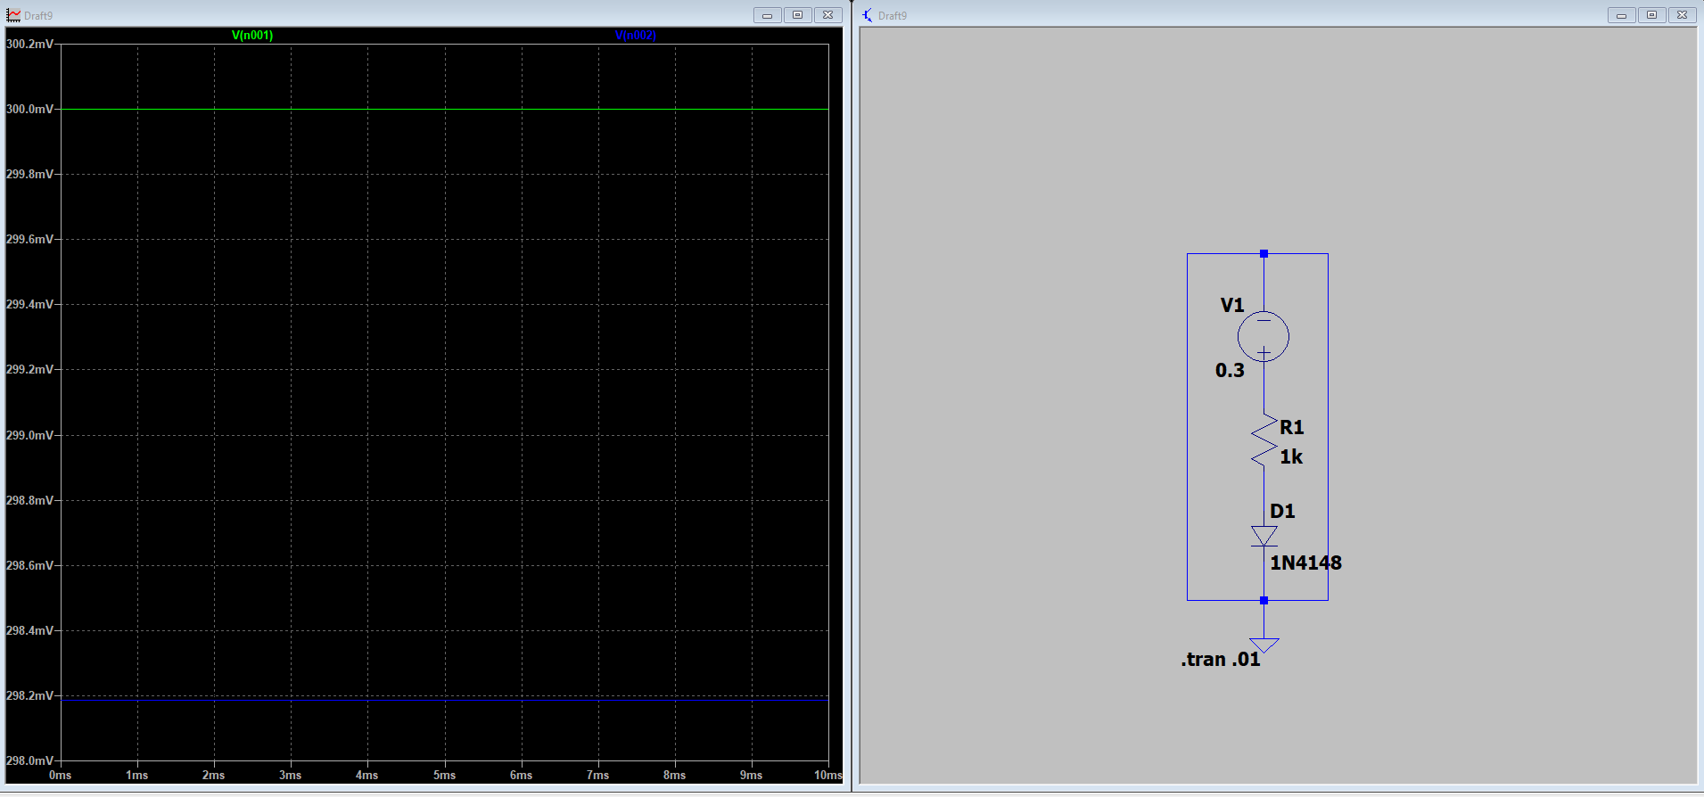

0.3V

Page7
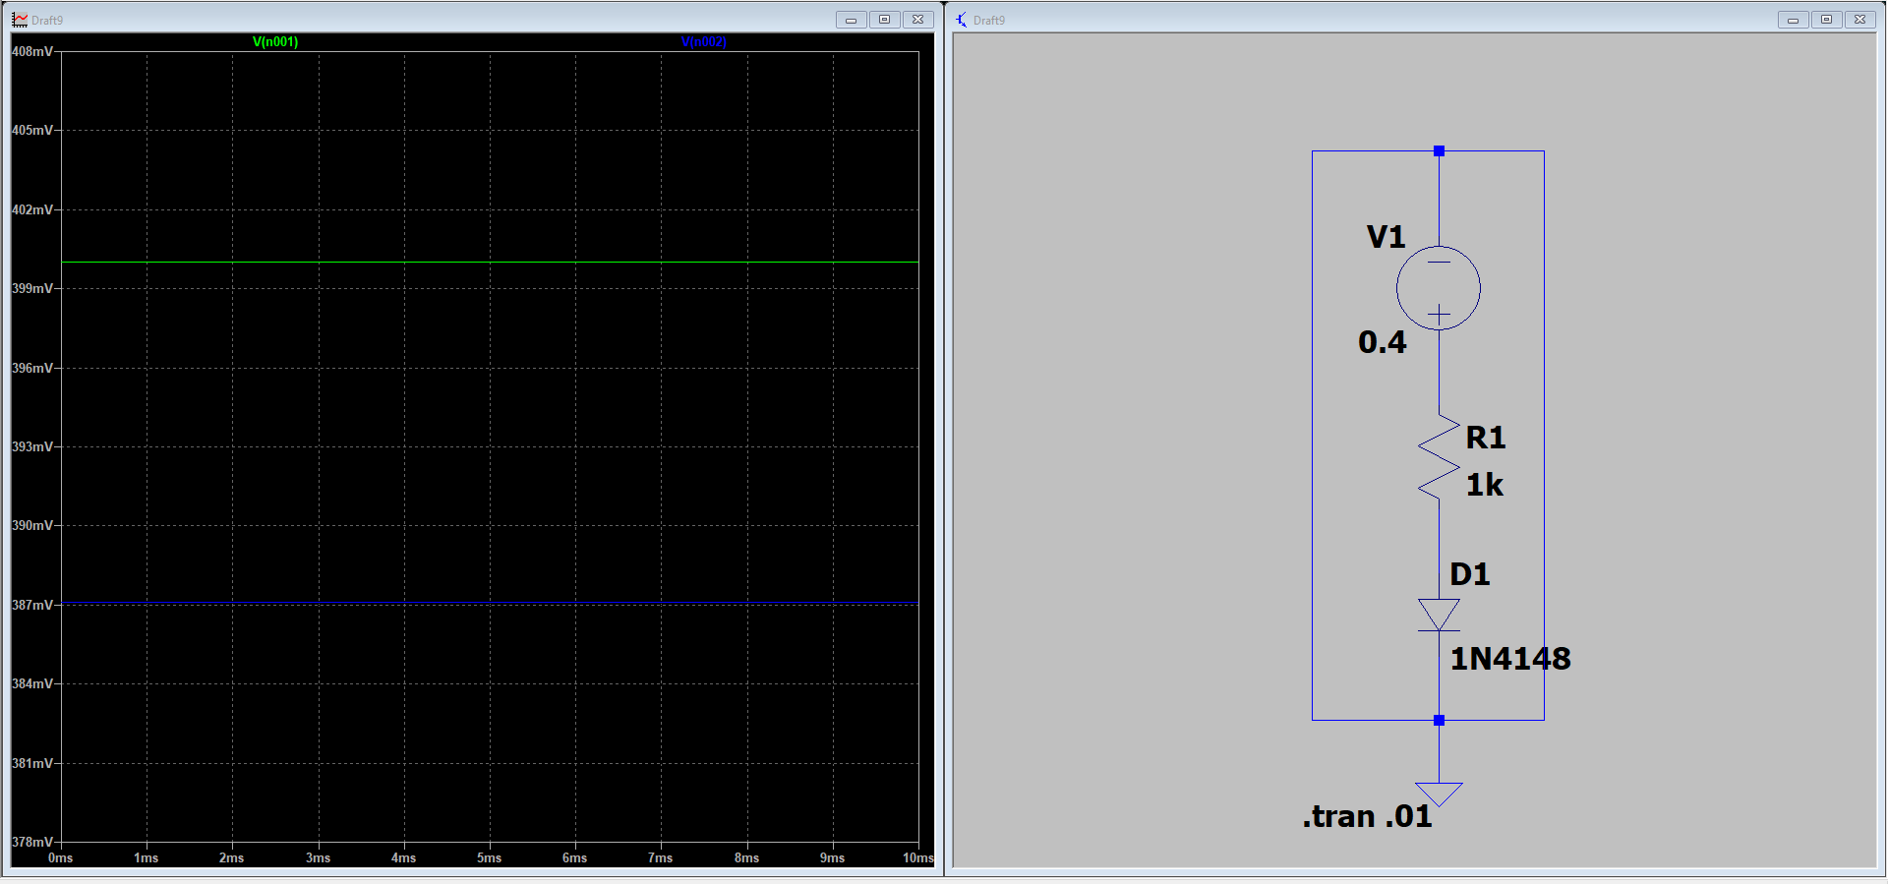

0.4 V

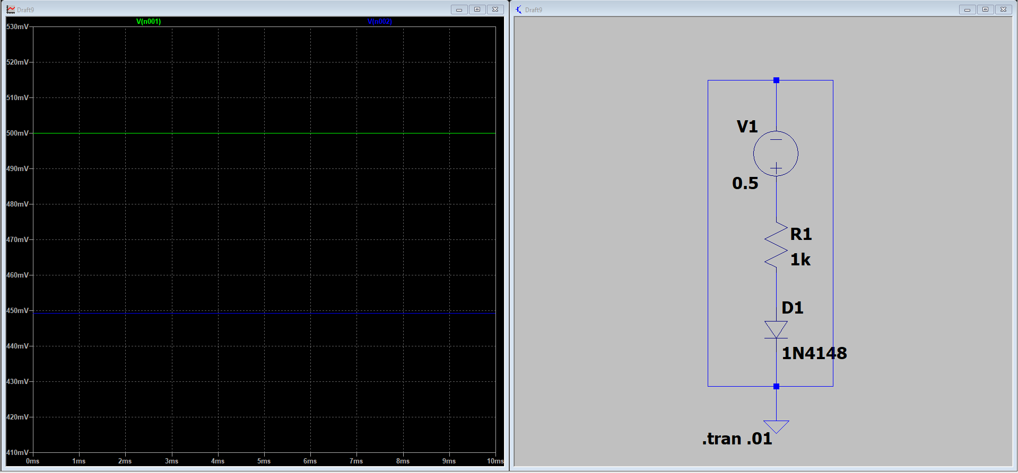

0.5V

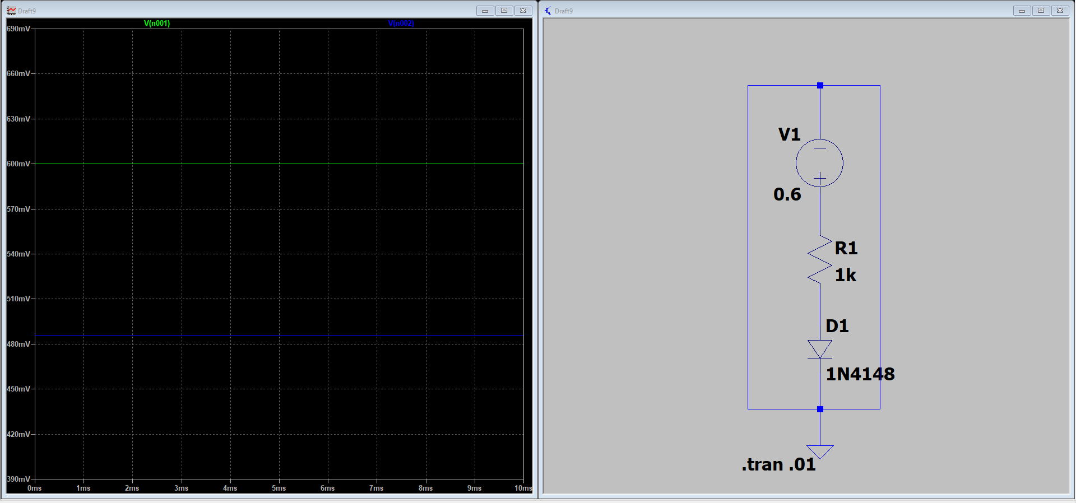

0.6 V
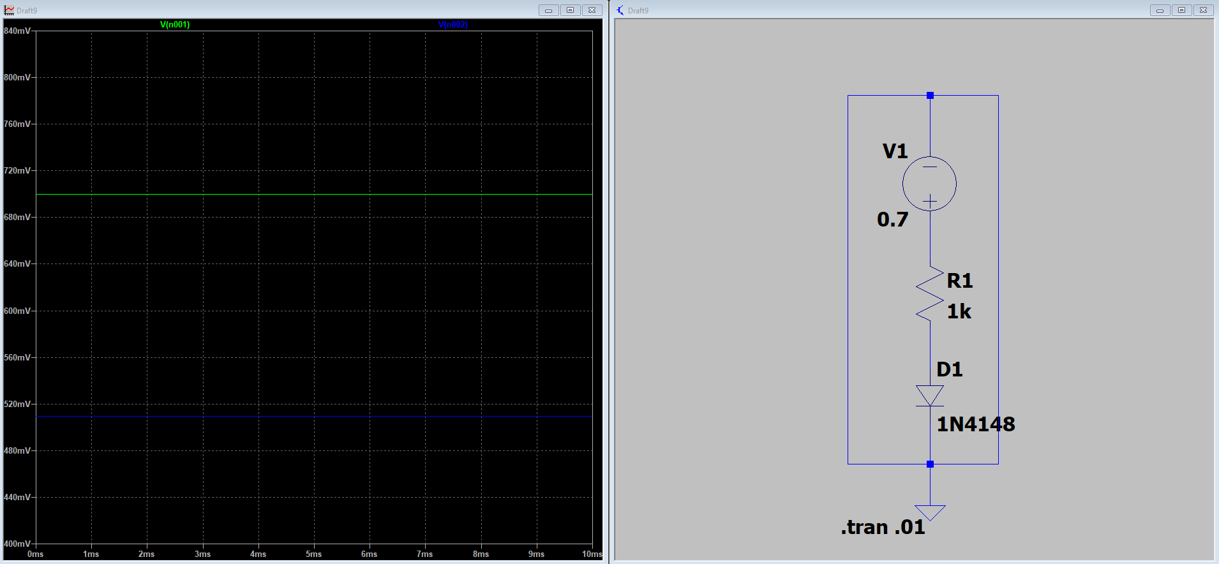

0.7V

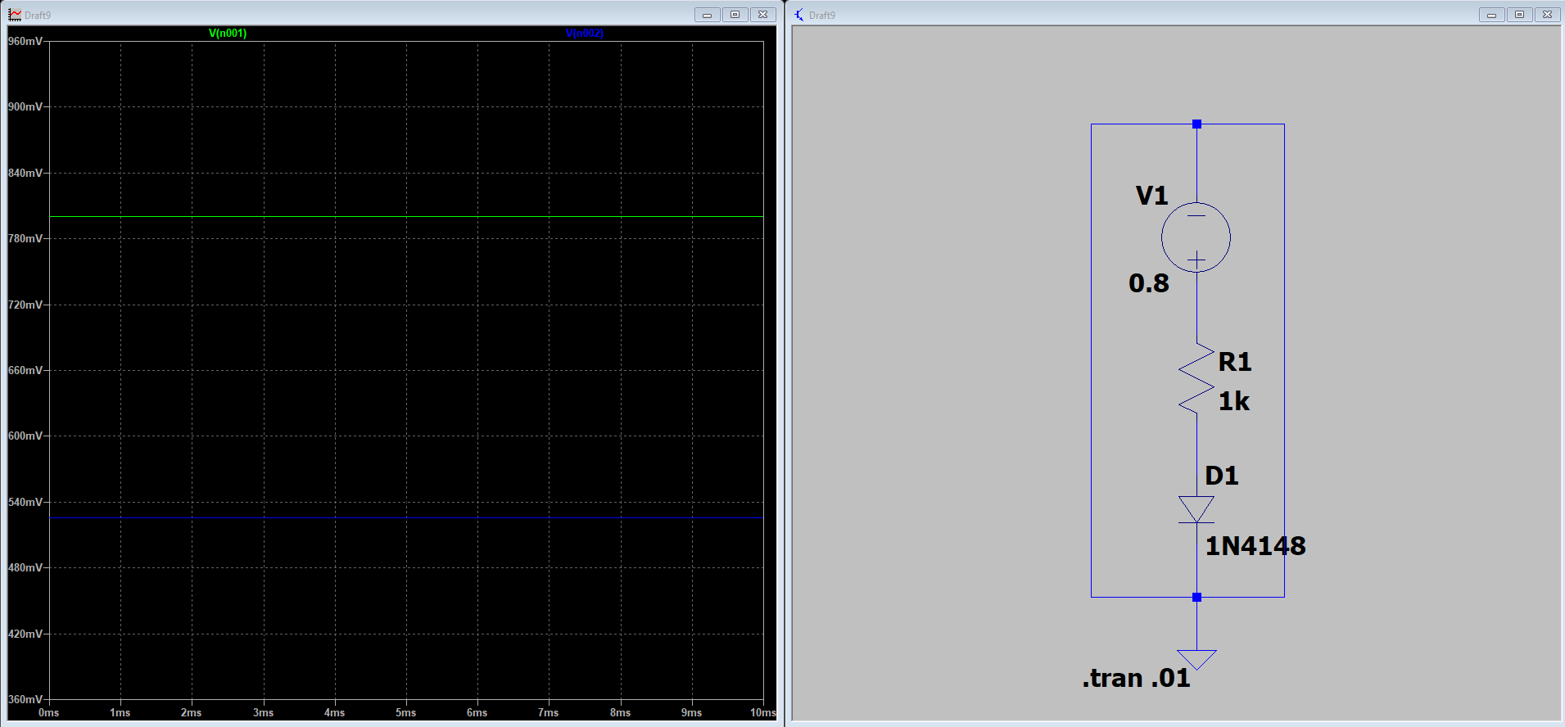
0.7V

0.8V
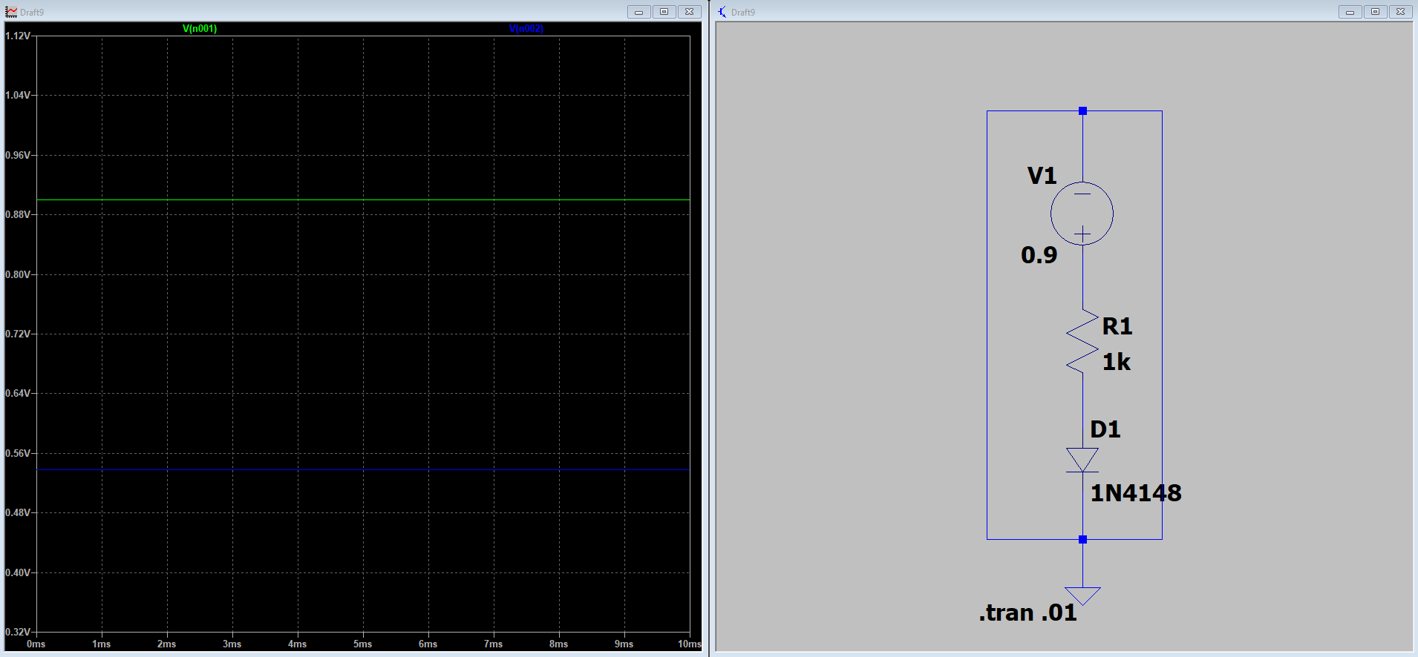

0.9V
Page8
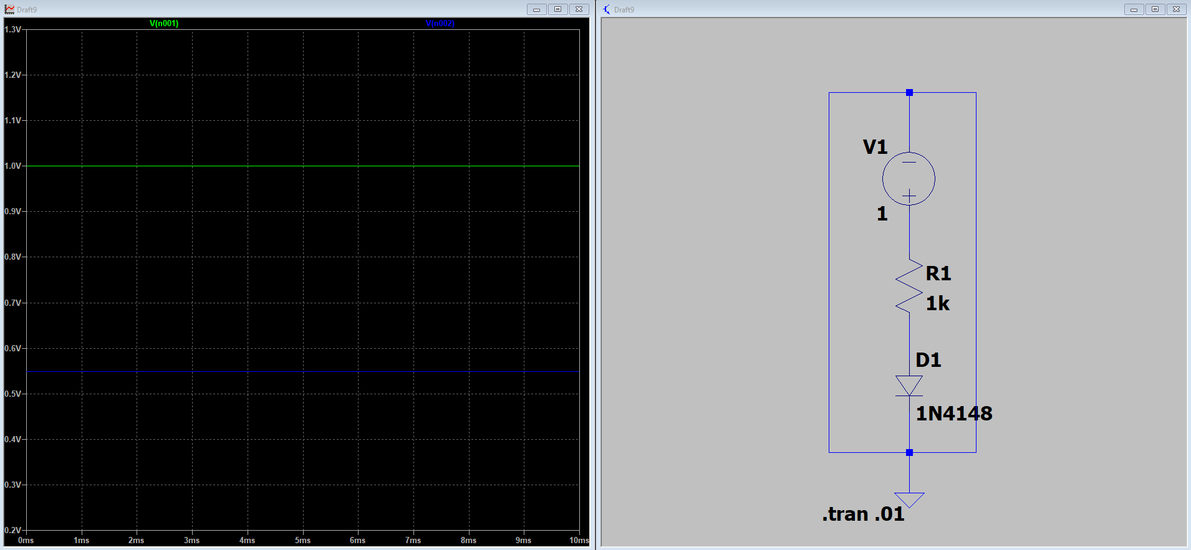
1V

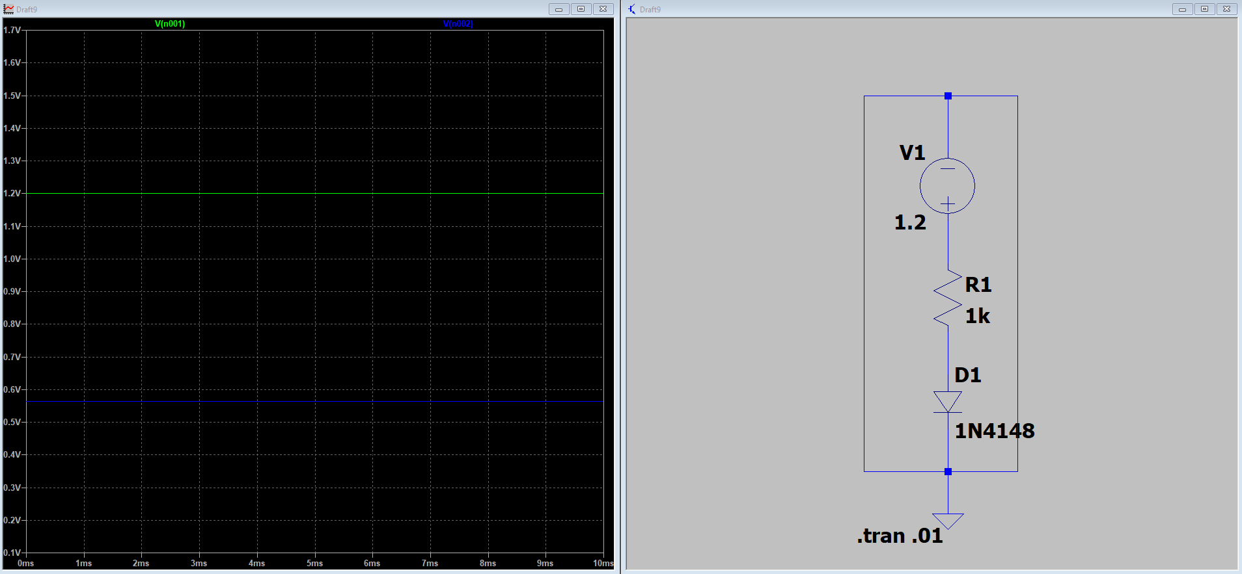
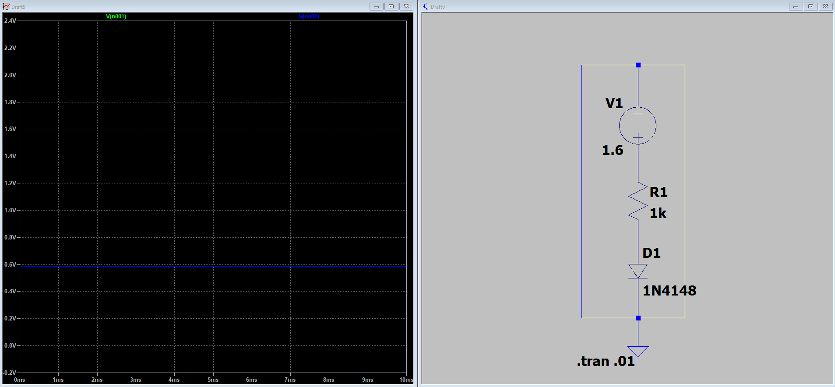
1.2V

1.6V

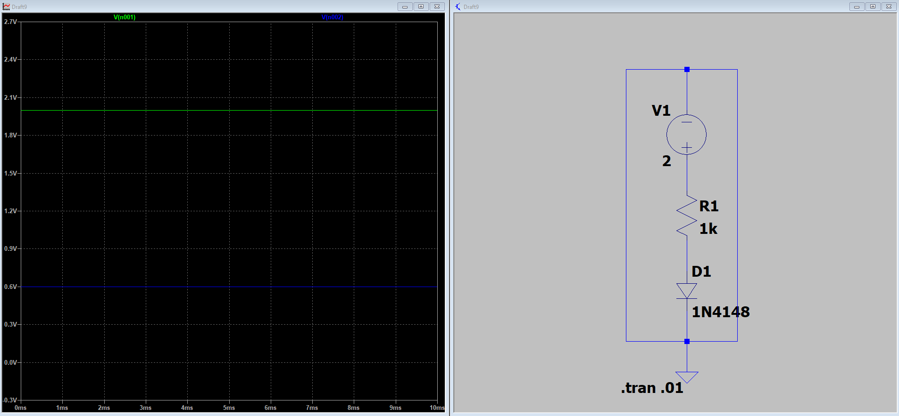
2V

Part 2

Normal Circuit

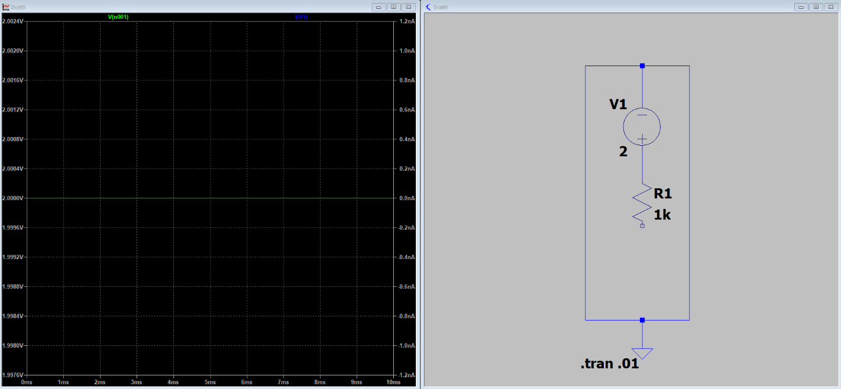
Open Circuit
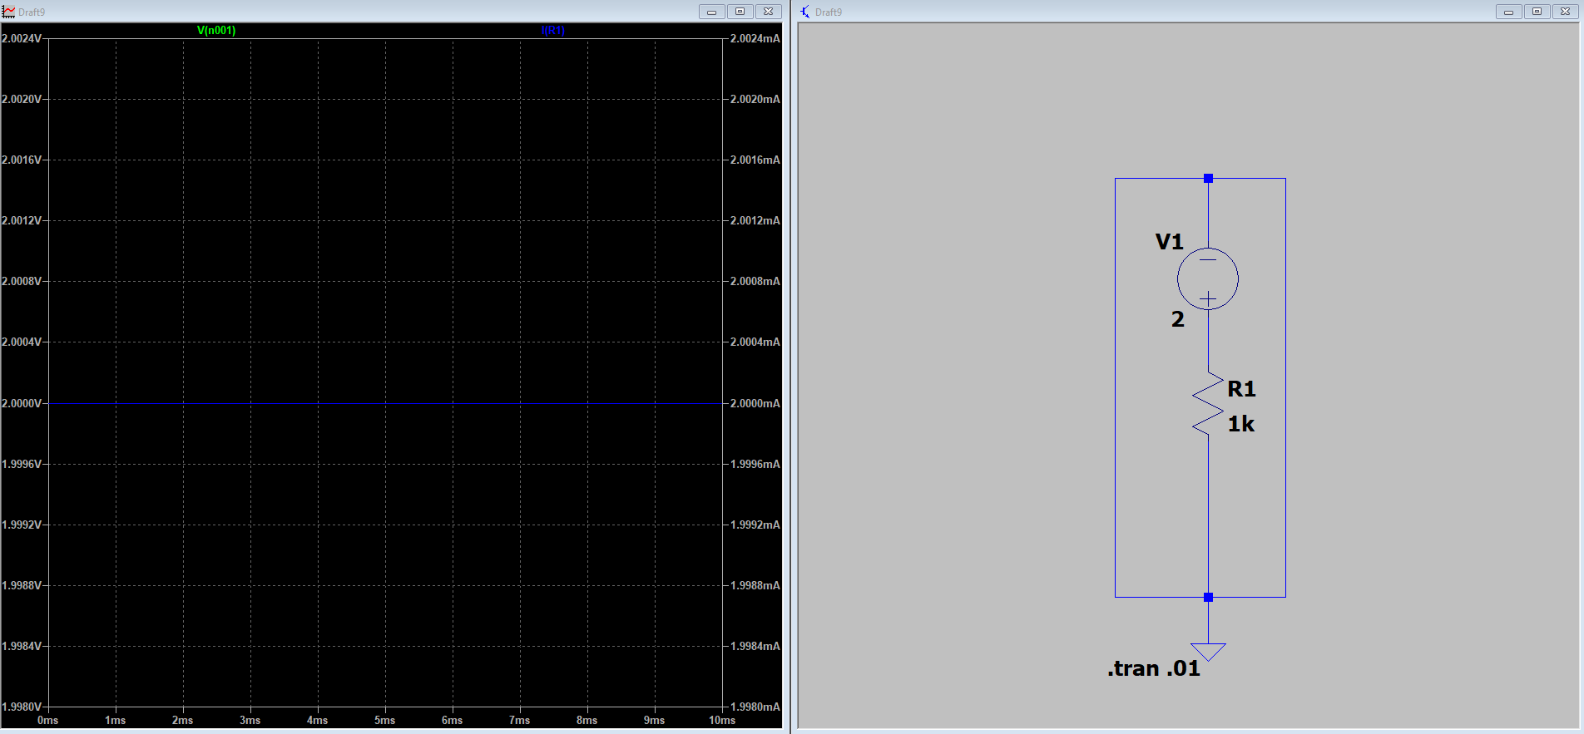

Short Circuit

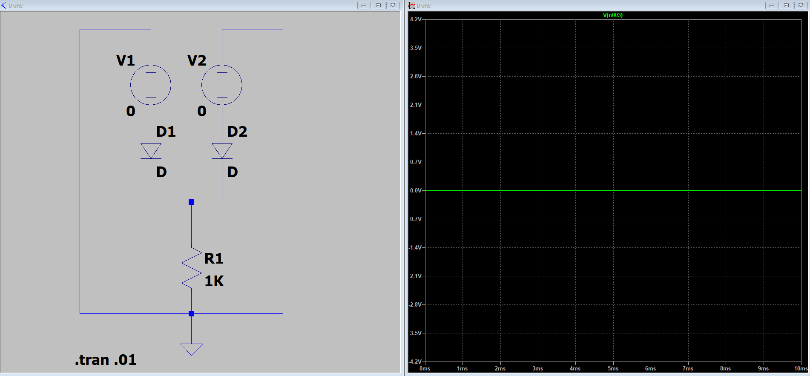
Part 3

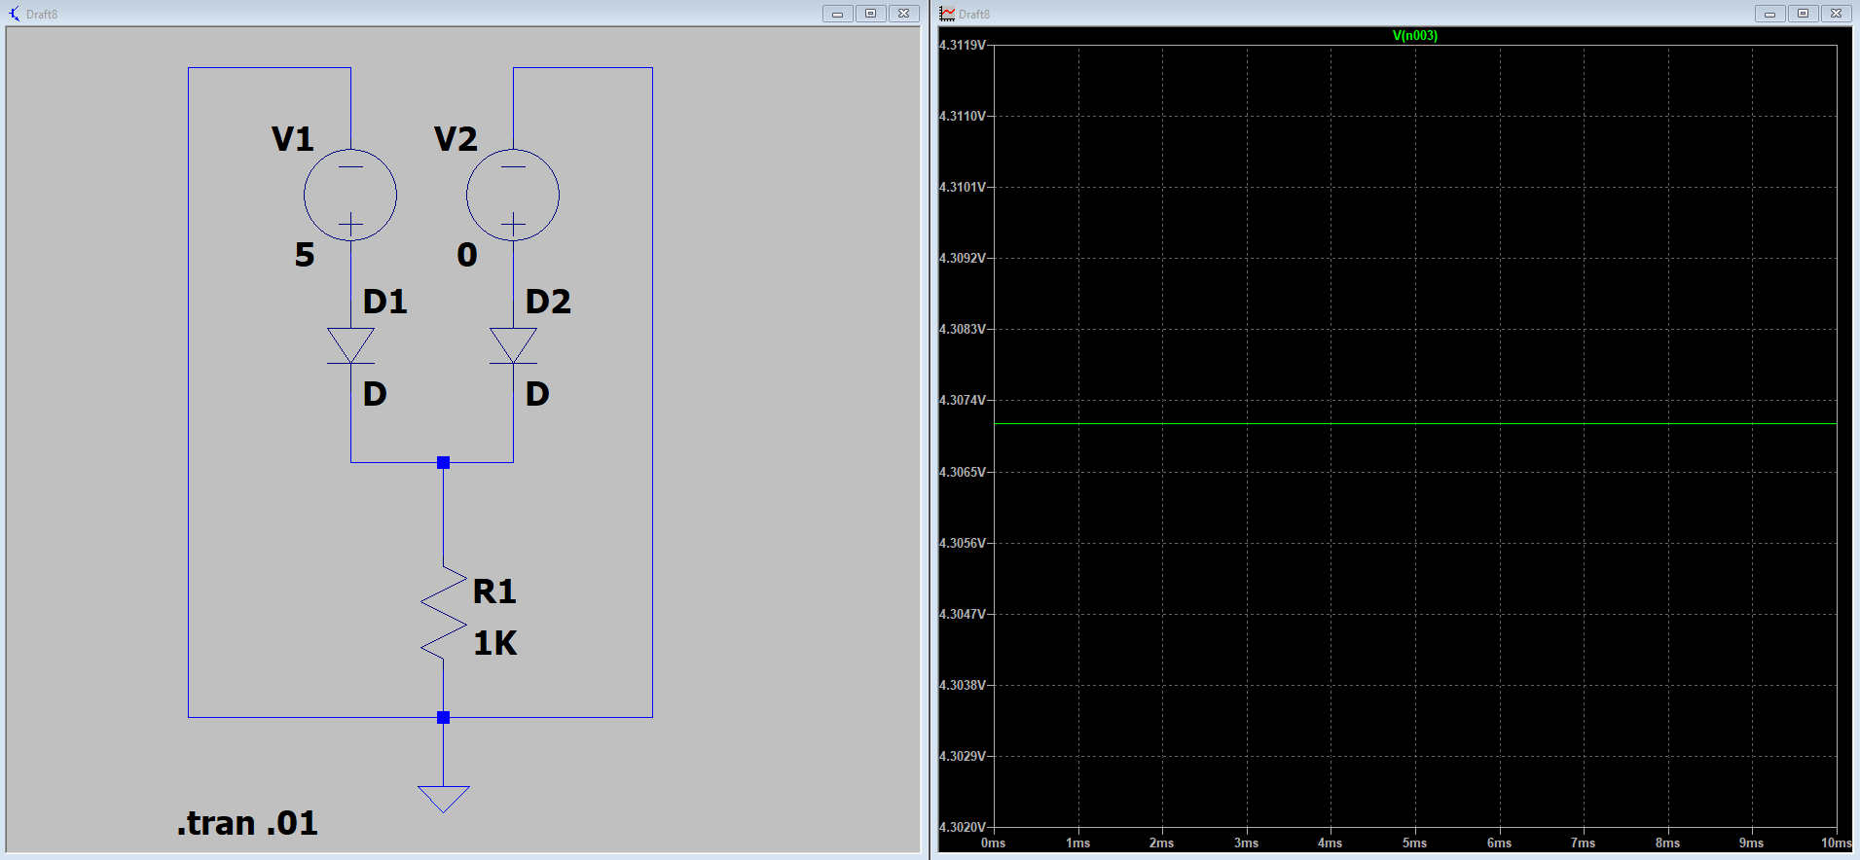
D₁ = 0V, D₂ = 0V

D₁ = 5V, D₂ = 0V

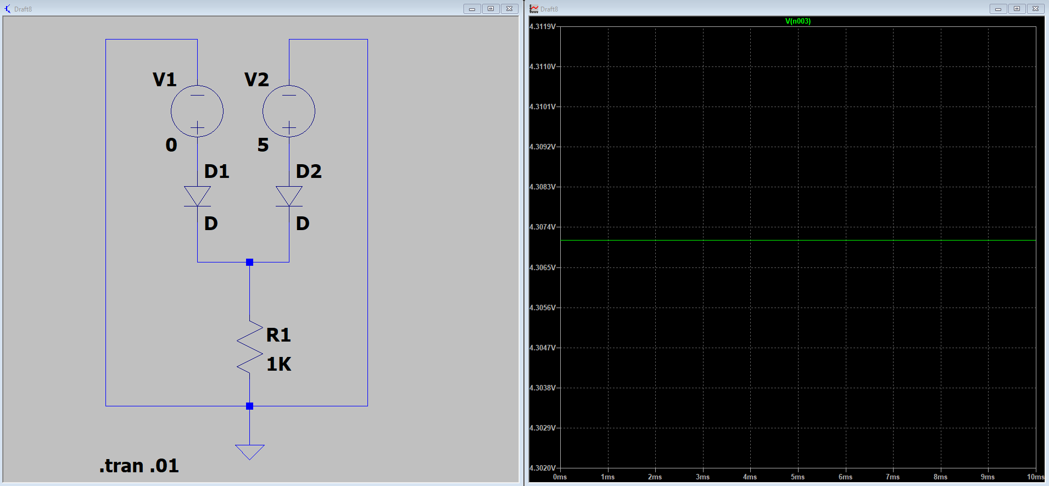

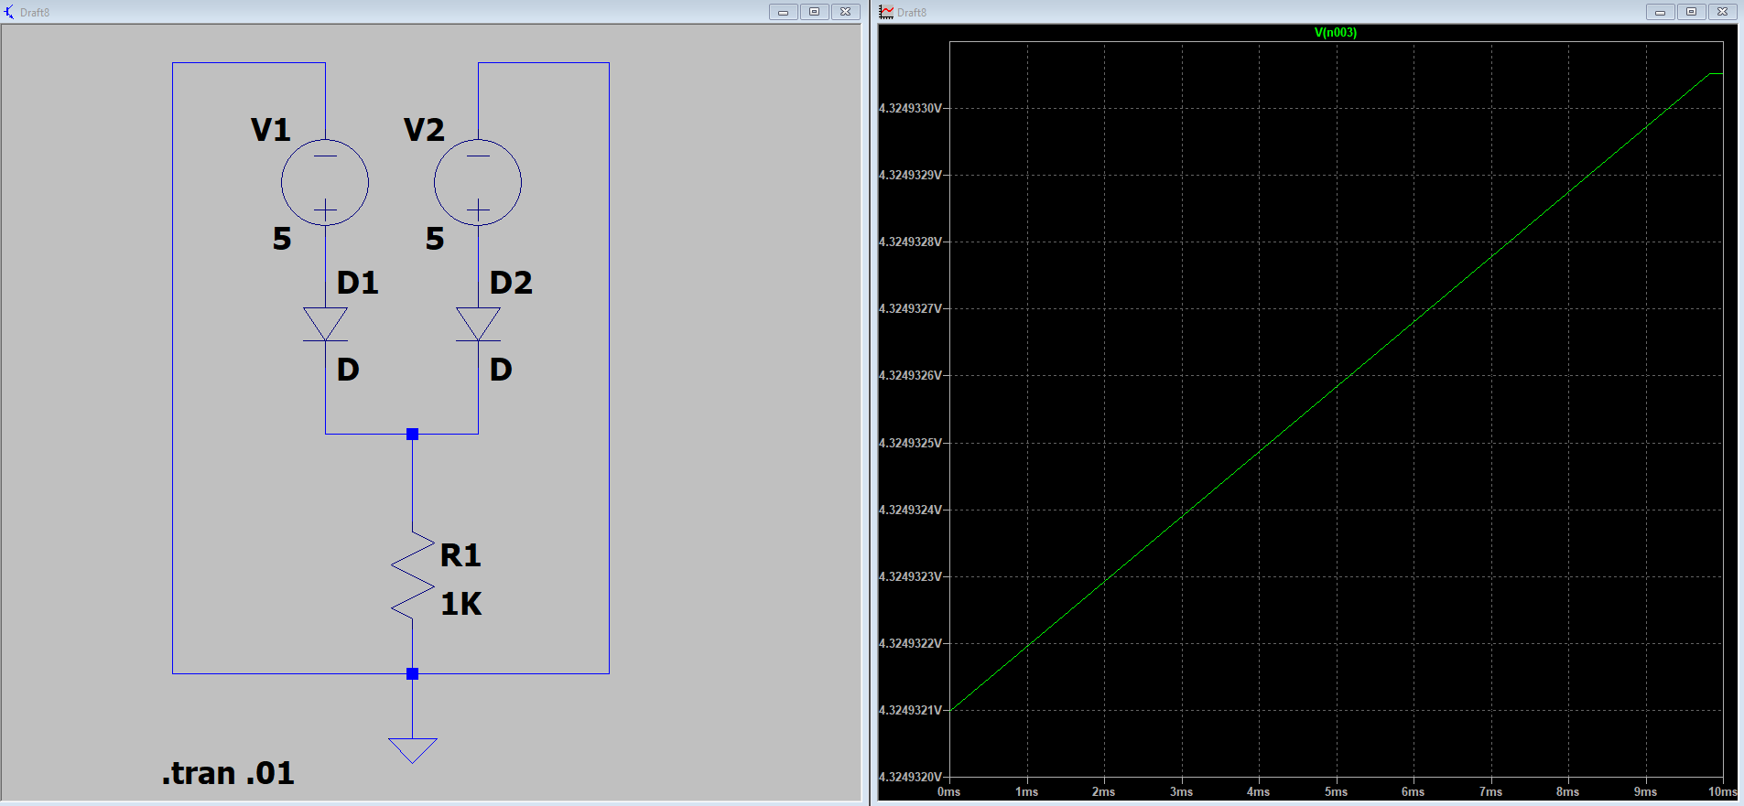
D₁ = 0V, D₂ = 5V

D₁ = 5V, D₂ = 5V



